IMDB Project:

1. Objective of project:
2. Predicting greatness of movie before release of movie.
3. Will the number of human faces in movie poster correlate with the movie rating?
4. Understanding of data.

24 – Attributes

1 – Target Variable

1. Data Cleansing and Preparation.
2. Data Exploration and Visualizations

* Actor rating

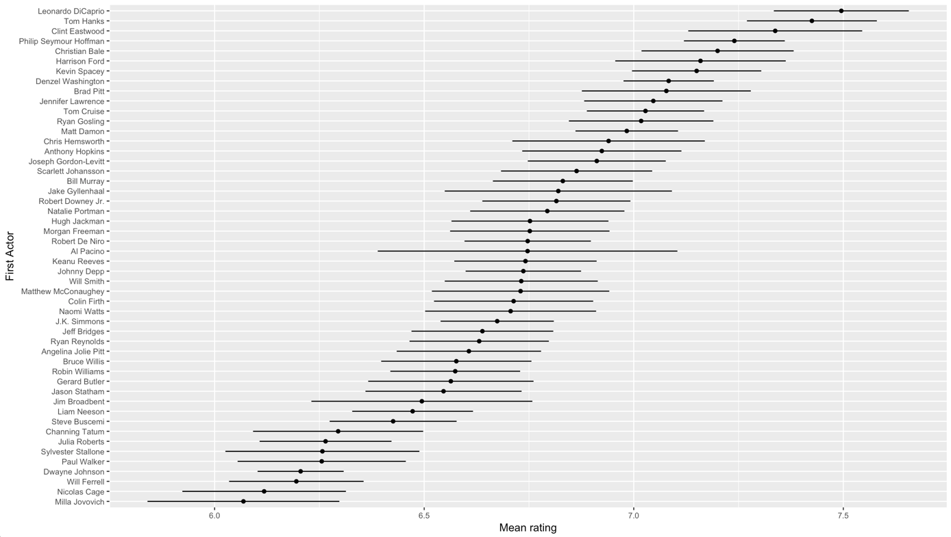

* Director Rating

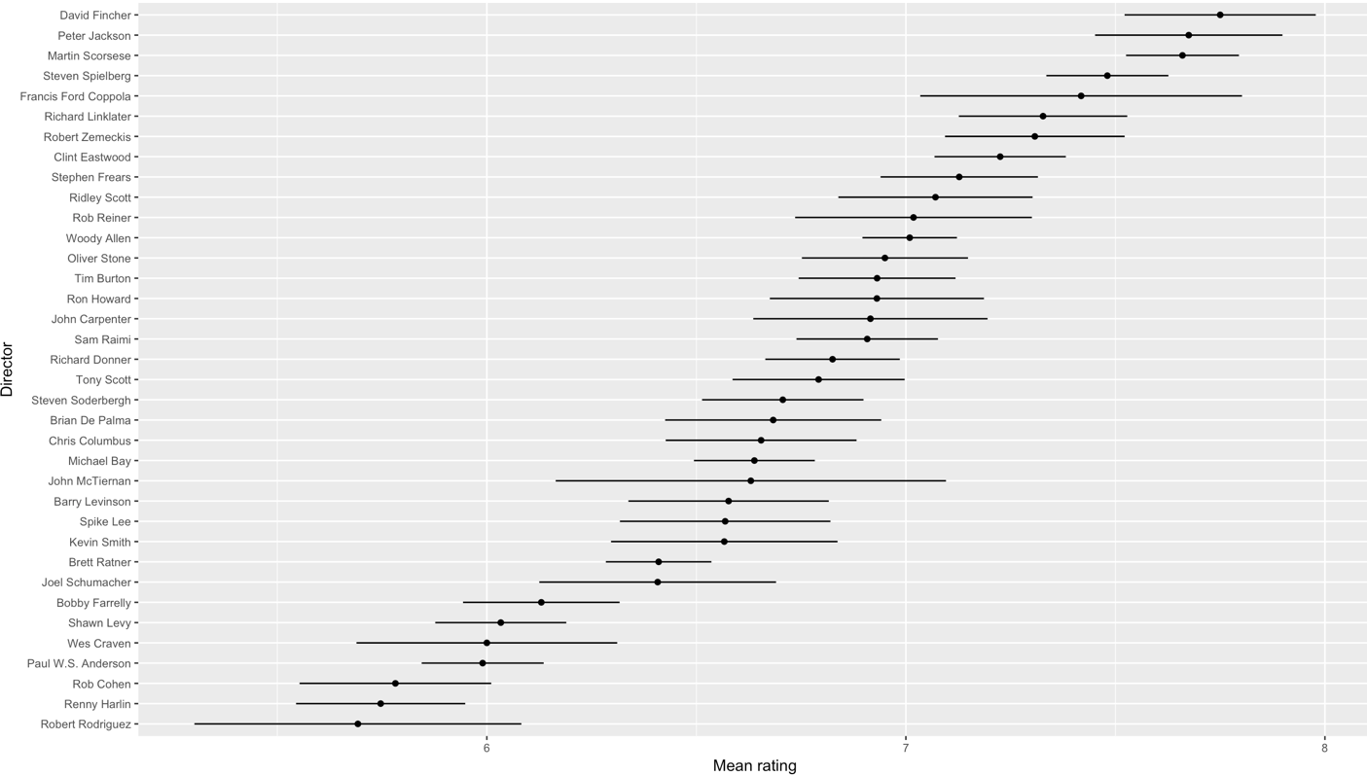

Keyword Analysis:

1. Feature Engineering:
2. [0 0 0 0 0, 000000,00000,00000]
3. Imputations.